
5E ELECTRONIC Co.
BUSINESS PLAN

Mehmet İveynat
Gökhan Toker
Ekim Kurtulmaz
Kaan Denizer
Serkan Atrek

Version 1.2
Table of Contents
1. Executive Summary ……………………………………………………………….6
2. Current Situation .....................................................................................................7
2.1. Basic Data of the Company ......................................................................7
2.2. Company Mission .....................................................................................7
2.3. Company Vision .........................................................................................7
2.4. Company Values ........................................................................................7
2.5. Company Goals ..........................................................................................8
2.6. Company Objectives .................................................................................8
2.7. Corporate Strategy ....................................................................................8
2.8. Location ......................................................................................................8
2.9. Organization and Management ................................................................9
2.10. Organization chart ..................................................................................9
2.11. Responsibilities of each executive officer ............................................10
2.11.1. Chief Executive Officer ..........................................................10
2.11.2. Chief Financial Officer ..........................................................10
2.11.3. Chief Technology Officers ………………………………….11
2.11.3.1. Hardware Designers ………………………………11
2.11.3.2. Software Designer …………………………………12
3. Product Definition ..................................................................................................12
3.1. Definition of the Product ……………………………………………….12
3.2. The standards of Product ……………………………………………...13
3.3. Quality Function Deployment …………………………………………13
4. Development Plan ...................................................................................................14
5. Marketing Plan …………………………………………………………………...15
5.1. Marketing Plan Summary ……………………………………………..15
5.2. Target Market ..........................................................................................16
5.3. Product Design ………………………………………………………….17
5.4. Pricing Strategy ………………………………………………………...19
5.5. Distribution Strategy ...............................................................................21
5.6. Promotion Strategy …………………………………………………….21
5.7. The Competitors ………………………………………………………..22
5.8. Sales Strategy ...........................................................................................23
5.9. Revenue Model ………………………………………………………….24
6. Financial plan …………………………………………………………………….24
6.1. Financial Plan Summary ………………………………………………24
6.2. Economic Condition of Turkey ………………………………………..25
6.3. Funding ………………………………………………………………….25
6.4. Assumptions …………………………………………………………….26
6.5. Supporting Documents and Financial Analysis ………………………27
6.6. Investment……………………………………………………………… 27
6.7. Break-even Analysis ……………………………………………………28
6.8. Financial Ratios ………………………………………………………...29
7. SWOT Analysis …………………………………………………………………..30
7.1. Strengths ………………………………………………………………...30
7.2. Weaknesses ……………………………………………………………...30
7.3. Opportunities …………………………………………………………...30
7.4. Threats …………………………………………………………………30
8. Conclusion ………………………………………………………………………...31
Appendices………………………………………………………………………….. 32
Appendix A: Variable Costs ………………………………………………………..32
Appendix B: Sales Budgets …………………………………………………………33
Appendix C: COGS Budget ………………………………………………………..34
Appendix D: Income Statements …………………………………………………..35
Appendix E: Selling and Administrative Budget …………………………………37
Appendix F: Cash Flows ……………………………………………………………39
Appendix G: Profitability Ratios …………………………………………………..42
Appendix H: Summary of Financial Projections………………………………….43
Appendix I: Development Plan .................................................................................44
References …………………………………………………………………………...45

1. Executive Summary
5E Electronic Co. has been founded by 5 shareholders in order to cope with the administration issues and producing issues. The main aim of the company is to produce innovative and cheapest electronic board in the market that can meet the demand.
5E Electronic Co. focuses on producing beneficial and useful electronic board to their customers. The financial analysis results have shown that approximately 2000 units can be sold per year to profit after 17 months. Considering the economical situation and the increment in the buying power of the customers in the last few months, the target value of the break point seems to be achievable because the price of electronic goods are usually stable.
The target customer of our company is private high schools, universities and companies. Considering the importance of educational issues and customer’s need to use or buy the equipment, the company would be able to sell its products directly to customers and make profit.
Aim of the 5E Electronic Co. is to have the most of the share in the electronic board market in Türkiye. The electronic board we are planning to produce helps to presenters and teachers to depict the issue better. Our product applies writing erasing and saving everything on computer and it can be sent via internet. The benefits of the product are known but because of its high cost it is hard to buy for customers. However, when the affordable electronic board is produced by 5E Electronic Co., customers will be tend to buy the product.
The power of innovative thinking and serious research of the market is done by the establishers of the company to establish 5E Electronic Co.. Considering the capabilities of the company, the innovative product that is designed, 5E Electronic Co. aims to dedicate itself to serve for the educational sector and business sector.
2. Current Situation
2.1. Basic Data of the Company
Name of the company: 5E Electronic Co.
Location: İstanbul
Sector: Electronics
Head Office: Şişli, İstanbul

2.2. Company Mission
Our main ambition is to make teaching and being taught easier and better by using technology with reduced cost. We increase the education quality for every student. It is important to be reliable and to provide customer satisfaction for us. In the light of this vision we want to become best company in this sector.
2.3. Company Vision
Our firm aims to improve education system by selling the Electronic Tables with reduced cost. The product has many useful properties that have benefits for both teacher and students. We try to produce and universalize our product in principles of quality, reliability and business ethics.

2.4. Company Values
- Respect to customers
- Honesty
- Reliability
- Accessibility

2.5. Company Goals
- To make teaching and presenting easier and better
- To produce the most affordable and useful electronic boards
- To make electronic board prevalent
- To mobilize and innovate electronic board market

2.6. Company Objectives
- Innovating electronic board to make it more useful
- Reducing cost of electronic board to encourage customers to buy the product
- Becoming a reliable and great company in market

2.7. Corporate Strategy
The main focus of the corporate strategy of the company is to make our company leader in electronic board sector. In order to perform this target, we try to introduce our product to all potential customers and sell our product in large quantities to spread our brand.

2.8. Location
5E Electronic Co. chose Şişli İstanbul to establish the company. As it is known İstanbul is the city that has the highest population. In addition to that, the number of companies, private high schools and universities are so much in İstanbul which are the target customers of 5E Electronic Co.. These are the benefits of the location place chosen. On the other hand, rental costs are very high in İstanbul, especially in Şişli. However, according to financial plan that is prepared by CFO of the company, the profit that the company can earn will meet the expenses of rental costs.
2.9. Organization and Management
5E Electronic Co. is formed by 5 engineering students. Each person in the organization has different duties, disciplines and skills. Responsibilities of members of company are as described under the title “Responsibilities of each executive officer”.
For the purpose of starting up the company, 5 establishers will manage the company and no major employment is necessary for short term period. The members of our team will help each other when a member confuse about an issue and can solve many possible problems by cooperating.

2.10. Organization chart
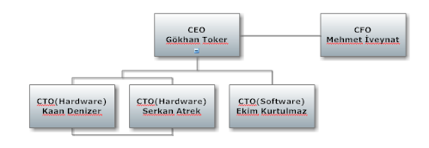

2.11. Responsibilities of each executive officer
2.11.1. Chief Executive Officer
Gökhan Toker is the CEO of the company because he will know more information about our product that is given by other officers and his communication skill is adequate to handle the CEO role in our team. He believes that team work and being in equal position of publishers of the company have many benefits to improve the company. In addition to that, he thinks that being cooperative in the team will help us to overcome possible problems. On the other hand, he believes that mistakes of officers should be punished and good works of officers should be awarded.
Gökhan Toker should obtain knowledge about the all operations in the company by reporting to him to estimate future changes and to plan future objectives. His responsibilities is listed as follows;
- Leadership
- Vision
- Correlate between organization and customer
- Decision-Making
- Management

2.11.2. Chief Financial Officer
The Chief Financial Officer (CFO) of 5E Electronic Co. is Mehmet İveynat and he is a member of the board of directors. He takes the responsibility of financial decisions, so he is called as financial director in the company. He manages the financial risks of the business. Generally, he performs his duties by making financial plans, analyzing financial records, following financial market, and forecasting about sales.
One of the most important duties of CFO is controllership duty. That duty makes him responsible for reporting financial information of the company. Every member of management will rely on the correctness and suitability of this financial information. Therefore, the reports should be the true data, because many decisions will be based on it.
Mehmet İveynat is also responsible for current financial condition and financial future of the company. He will decide how to invest the company's money. Therefore, it is included that economic forecasting will be predicted to make the company's success in the future.

2.11.3. Chief Technology Officers
Chief Technology Officer (CTO) is a high position in a company whose responsibility is focused on scientific and technological issues in an organization. It involves overseeing Research and Development activities, and determining long term visions and strategies. They combine a strong technical or scientific background.

2.11.3.1. Hardware Designers
We have two hardware designers in our team whose names are Serkan Atrek and Kaan Denizer. They are responsible to design hardware of the 5E Electronic Board by combining physical components of the electronic board. Having two CTOs to design hardware from different disciplines will give the chance of designing better electronic board hardware. Also they can reduce the cost of our product by selecting not only useful but also cheaper components.

2.11.3.2. Software Designer
Software designer of our team is Ekim Kurtulmaz whose major is Electrical and Electronics Engineer but he is good at using programming languages such as C++, Java, and so on. CTOs will determine the functions of 5E Electronic Board together and Ekim will be responsible to design software of our product.

3. Product Definition
3.1. Definition of the Product
Our product is basically a smart board system that is designed to be used in lectures and conferences. Main idea of our system is to capture the movement of the colored board marker on a regular board and save these movements as images in a computer. According to our design, two wide-angle cameras (one camera for each axis) that are placed up and right edges of a board will catch the motion of the certain axis movements of a colored board marker and send images simultaneously to the computer. Afterwards both images will be cropped to adjust the range we want to process. Then the images will be digitally processed by the algorithm that we create so we can find the location of the colored board marker by using a software program. To do these image processing operations, we are considering c++ and opencv. The algorithm will detect the color of the pencil. By using these, we will determine x and y axis of the board marker according to a virtual origin on the board. This data will be used to draw what is on the board pixel by pixel. To manage the drawing action on computer, we plan to create our own drawing program with java or c++ since communication with “Paint” may cause some problems. In addition, if we want to track our colored board marker, we have to pick a color that can always be distinguished from other colors in any time of the day. We have to avoid light reflections and shadow effects to get the perfect result. We also need to be careful about the calibration of the cameras. After successfully building the basic design, there are some applications that we would like to add to improve our product. Different writing color and eraser applications are some of them.

3.2. The standards of Product
There is a small amount of radiation that every people exposed during daily life which is called background radiation or natural radiation. Our Smart Board system produces less than 1m-rem (Rontgen equivalent man) which is around natural radiation.

3.3. Quality Function Deployment
In order to clarify the complete cycle of our board, we have focused on the criteria’s which was mentioned in the quality function deployment which were;
- Creating a design that meets our customer needs.
- Conducting detailed product analyses of our product’s parts and components.
- Identifying the process necessary to be able to make the product.
- Upgrading the requirements of the product.
For investigating reliable and successful house of quality 5E Electronic Co. made customer surveys for our product Smart Board, and with the results of the surveys we conclude the “WHATS” which is the requirements of the customer for our product. Before the surveys we briefly told our product, we try to make an idea of affordable boards. Then we told about our competitors and the other smart board to make our survey objective and reliable. Also we told the other board’s features and prices of other boards. Then we request them to be objective in the surveys.
These surveys helped us to realize the recommendations, comments and demands of our product. We did our survey through phone, mail, and face to face. Our target was from different ages, sex and education. However, we specially try to ask our questions to instructors and student which are the potential users of our product.

4. Development Plan
Our company 5E ELECTRONIC CO.’s schedule is given in the Appendix I. Our development plan consists of 8 main stages. They are, Formalization of the 5E Electronic Co., Researching the market, Electronic research followed the market research and we moved on with Vendor research and Business Plan. Next semester we are planning to move on to our project with the Implementation, Production and Marketing. At the end of the Spring semester 5E Electronic Co. are planning to conclude all its phases.
In the first semester, we have created our company, because we were five engineers we decided to name our company 5E Electronic Co. then we have researched the market and we have analyzed our competitors then we have analyzed the electronic parts, hardware and software analyzed were important during this phase. By the expenditure plan we have done the Vendor research and we moved on the Business plan writing. Through this stage all the company members worked hard and all future steps had taken into consideration, all the developing plans had been created in details.
In the second semester, Implementation is our milestone in our development plan. We are planning to do hardware and software implementations, then we are planning to do hardware and software integration then quality & controls are going to be our next step. After the simple production stage we are going to move on to production stage which is going to be very hard and we have to be careful during the production stage. While the implementation, production stages are going to move on, we are going to start to marketing of our product.
Whole development plan of our company is in Appendix I.

5. Marketing Plan

5.1. Marketing Plan Summary
5E Electronic Co. knows that marketing is a key part of business success and marketing plan will be used as a basis for executing marketing strategy. To introduce our marketing strategy, we prepared this marketing plan and it includes eight main topics that are;
- Target Market
- Product Design
- Pricing Strategy
- Distribution Strategy
- Promotion Strategy
- The Competitors
- Sales Strategy
- Revenue Model

In this report, there can be found many information such as market research about similar products, competition of 5E Electronic Board in the market and forecast for a period of five years of this new established company named 5E Electronic Co.

5.2. Target Market
Electronic board market has a wide range of products that have different properties. In addition to that, the number of companies that produce electronic board is above 20. We searched the companies and their product from internet. Also we sent emails to some of the companies about their market share in Türkiye but they were not informed us about the issue. We got information about prices, properties and designs of products of different companies with our own opportunities.
Our product is for both Consumer and Business. Our target customers are educational institutions such as universities, high schools and companies which need smart board for their daily, monthly or annual educations. We chose İstanbul for our location because the number of companies, private high school and universities is more than the other cities. We will meet some of these companies and schools to make known and advertise our product. Also we will inform customers about how to use smart board and benefits of using the product. Customers who are interested in our product can buy our product via our website, electronic warehouses and directly from our office in Şişli, İstanbul. In addition to that, we can send our product to the customer from all over the world who gives order from internet. Customers will pay the price of the product on the spur of the moment by cash, cash card and credit card. However, customers who purchase the product from our website can only pay with credit card or cash card.

5.3. Product Design
Our Electronic board system consists of two cameras and two board marker. Properties of the cameras are same but one of the board marker is red and the other on is green. Main idea of our system is to capture the movement of the red colored board marker on a regular board (height is 1 meter, length is 2 meters and depth is 2 centimeters) and save these movements as video format to a computer. According to our design, two Microsoft Liftetime Cinema Webcam H5D-00001 cameras (one camera for each axis) that are placed up and right edges of a board will catch the motion of the certain axis movements of a colored board marker and send images simultaneously to the computer by USB 2.0 ports. Then the videos will be digitally processed as images by the C++ algorithm that we create so we can find the location of the colored board marker by using a software program. To do these image processing operations, we are using opencv library. The algorithm will detect the red colored pencil. By using these, we will determine x and y axis of the board marker according to a virtual origin on the board. This data will be used to draw what is on the board pixel by pixel. To manage the drawing action on computer, we plan to create our own drawing program with C++ since communication with “Paint” may cause some problems.

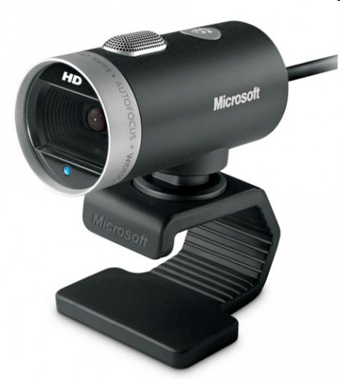
Figure 1: Microsoft Liftetime Cinema Webcam H5D-00001


Figure 2 : Colored Board Marker

The packaging of the product will be small as possible it is to make it more portable. In addition to that, having a small package will reduce the storage cost per product. The dimensions of the packaging will be 25 cm height, 30 cm length and 10 cm depth. To prevent the risk of breaking of the product we will clothe all individual parts with nylon bubble barrier and Styrofoam. On the box there will be the picture of our product and write our name of the company, name of the product, contact address, telephone and e-mail address.
Transportation will be via cargo to all our customers. Delivery time is maximum three days for all cities in Türkiye. Sending to abroad will take up to ten days. We guarantee to change the product free of charge if our product is broken when customer takes the cargo and the customer has report of proceedings about broken product when they get the product.

5.4. Pricing Strategy
5E Electronic Co. decides to sell the product 5E Electronic Board for 599 TL. However, there will be some discount for lumping sale. The price ceiling will be 599 TL and the price floor will be 549 TL. 5E Electronic Co. determines the price of the product after making market research. Prices of electronic boards which are produced by some companies are listed on the chart below;

As shown on the chart, the cheapest one is 5E Electronic Board because the aim of 5E Electronic Co. is to have a big market share in Türkiye.
The current price of 5E Electronic Board is 599 TL. When inflation rate of Türkiye is considered, there will be accrual approximately 6.5% per year if it is necessary. However, it is not certain to increase the price about 6.5% per year.
There will be no cost for transportation to 5E Electronic Co. because customers who buy the product will pay the price of cargo. Detailed information about transportation of the product is given under the “Distribution Strategy” title. In addition to that, there will be no cost for agent commissions because the product will sell to customers directly.
The administrators of 5E Electronic Co. think that the price of the product is conceivable. However, if the company encounters with unexpected situation such as low number of sales or economic crisis, The Company will reduce the price of the product to price floor which is 599 TL.

5.5. Distribution Strategy
Most of the sales will be through personal contacts and online orders. The distribution of the product will be done by a cargo company. After the research about the cargo companies, it is found out that price of the delivery of one unit of our product will be around 5 TL but Yurtiçi Kargo makes 35% discount to their contracted customers. Therefore, the cost of cargo per our product with Yurtiçi Kargo is about 3,30 TL. Customers who buy our product will pay the cost of cargo. This strategy works for the best for Electronic Board since there will be no cost for our company and there is no need to allocate a distribution budget.

5.6. Promotion Strategy
5E Electronic Co. realized that good marketing strategy of the product is important as much as the quality of the product. Being a new company with almost no customer makes the promotion strategies vital to advertise and to gain reputation in the market. A few different strategies are designed for our product Electronic Board.
For our product the most important strategy is going to be advertisement through brochures. We will dispatch brochures to companies, private high schools and all universities in İstanbul. We will inform our target customers about usage of the product, advantages and technical properties of the product. We think that result of dispatching brochures will make customers interested in our product. In addition to that, brochures will tell that we will make presentation about 5E Electronic Board for free. We thought that brochures would be the best promotion strategy the initial months for our sales.
Another promotion strategy will be media advertising to newspapers. 5E Electronic Co. thought that our target customers will be establisher of companies, administrator of private schools and rectors and deans of universities and also we thought that newspaper reading rate of these people is high. That makes our advertising on newspaper about 5E Electronic Board more beneficial than advertising on radio, TV or magazine. The frequency of our newspaper advertisement will be two per week for first six months. One of these weekly advertisements on newspaper will be on Sunday because according to our research, the rate of selling newspapers for a week is higher on Sunday than other days of a week. The other day of advertising on newspaper will be random in week days.

5.7. The Competitors
Electronic Board is a new sector in the market. The sector started developing and several types of products that are used for education and presentation at schools, universities and companies. However, many of these products are too expensive and cheaper products do not meet the demand of customers. For instance, eBeam Classic Whiteboard lets users save, print, or share their whiteboard notes with anyone in the world like our product 5E Electronic Board. However, the price of eBeam Classic Whiteboard is between $2600 and $2900. That means if an owner of a private high school decides to buy eBeam Classic Whiteboard to all classes of school, he/she have to buy approximately 60 eBeam Classic Whiteboard and the cost of that expense is about $170,000 which is a big investment and hard to pay that amount of money at the moment. For the other producer companies of electronic boards such as IPBoard and 3M Digital board, the situation is same. In addition to that, these companies produce their product abroad they have some lacks about after selling service. If the same customer buys 5E Electronic Board, he/she will pay less than the quarter of the amount. 5E Electronic Co. tries to make electronic board common and to ease learning, teaching and presenting. That is why the price of 5E Electronic Board is the cheapest electronic board which is useful and functional. Also there will be no annoyance about after selling service because it takes a short time to receive broken electronic board and to send it back when it is repaired.

5.8. Sales Strategy
Short-term target customers of Electronic Board are defined as universities, high schools and big companies which are in İstanbul. Selling price of the product will be 599 YTL depending on the cost and on the market research. 5E Electronic Co. will sell the product via internet or personal contacts directly. Customers who buy 5E Electronic board can give feedback by sending e-mail, calling the office and talking face to face in the office. That will increase the effectiveness of relationship with customers.
In addition to the personal contacts, advertisements on newspapers, brochures and presentations about the product at schools, universities and companies will be an effective sales strategy. Presentations will be carried by engineers who are administrators in 5E Electronic Co. and that is not only to get valuable customers network but also increase the brand awareness of 5E Electronic Board. The most important advantage of presenting by engineers in administrative position is that these engineers have all knowledge about the product and they can give all necessary information about the product to customers.
Therefore, although advertisements on newspapers and brochures will bring many customers, one on one communication with customers will be a better way to sell the 5E Electronic Board.

5.9. Revenue Model
Although the range of target customers of 5E Electronic Co. is so wide, the Company considers universities, private high schools and companies as target customers for the first five year period. There are 139 universities, 188 private high schools and 25,927 companies with foreign capital (733,000 in total) in Türkiye. 5E Electronic Co. claims that 10% of these target customers are willing to buy the product and also supposes that it can be sold 50 units per university, 40 units per private school and 3 units per company on average. When it is calculated, it can be seen that approximately 9,260 5E Electronic Board can be sold in five years. Since the price of 5E Electronic Board is 599 TL, the sales revenue of the company is about 5,546,740 TL for five years. Cost of goods sold is 311 TL per unit and the total cost of goods sold is 2,879,860 TL. However, expect the cost of goods sold, there are many expenses such as operating expenses, operating toss and interest expenses which will be informed more detailed in Financial Plan. After these calculations, gross profit is about 2,666,880 TL and the gross margin rate is about 48%.

6. Financial plan
6.1. Financial Plan Summary
5E Electronic Co. prepared a financial plan for spending and saving future income for a period of five years. This plan allocates future income to various types of expenses, such as operating expenses and interest expenses and also reserves some income savings such as net sales and net profit. In the period of five years, first two years of the company’s income statement and cash flow statement were considered monthly and the last three years were considered yearly.
6.2. Economic Condition of Turkey
Since the beginning of 2009, the economic crisis has affected the entire world. Many nations of the world both developed and developing countries are affected from the crisis. The countries which have strong economic conditions have also suffered from the situation like United States of America. Turkey has also affected from the economic crisis but it has not reflected to inflation rate and unemployment rate. However, it has decreased purchasing power of people and exporting goods.
The main effect of economic crisis on Turkey is global economic slowdown. That has decreased the demand for Turkish exports. This also decreased the number of product produced in Turkey. Estimated unemployment rate for 2010 is about 10.5% which is less than previous years. In adition to that, estimated inflation rate for 2010 is 7.29% which shows that althoug the economic contidition of entire world Turkey is in a good position. Growing private sectors by selling some banks and communication sector also makes economy stable..
6.3. Funding
5E Electronic Co. is a new company in market and it is established by five young enterprising business men. Because of no enough funds the establishers of the company decided to take up a loan. As a result of the interviews which are done with banks Mehmet İveynat, the Chief Financial Officer of 5E Electronic Co., decided to take up a loan about 100.000 TL from Yapı Kredi Bankası. The expectation of Chief Financial Officer from the money taken from bank is to meet expenses for the first six months because it is forecasted that first 2 months there will be no goods sold and the company will start to earn money after six months from the beginning. The information about net profit can be found in Appendix D.
6.4. Assumptions
- 5E Electronic Co. Assumed that first two months workers of the company will focus on advertising and establishing and there will be no selling. In March, company will start to sell goods and when the product and the company getting famed it is assumed that the number of units sold will increase. Selling price is 599 TL for first year. According to last year’s inflation rate ,it is expected to be 6.5% for five years period of time on average and the price of a unit increases 6.5% per year.
- Cost of one product is about 311 TL for first year and it is also affected from assumed inflation rate. It is assumed that the cost of goods is 331 TL for second year, 353 TL for third year, 376 TL for fourth year and 401 TL for fifth year. It can be found in Appendix D.
- There will be no depreciation cost for the company because 5E Electronic Co. does not need to buy machines or equipments except office materials. That is why depreciation is not considered in the financial plan of the company.
- Operating cost includes renting office, salaries of workers, promotion and advertising costs, utilities and other unexpected costs. For the first year, renting costs is 2000 TL per month, salaries of per administrator are 4000 TL and salary of secretary is 2000 TL. It is assumed that all these operating costs will increase 6.5% per year according to inflation rate.
- The company allocates 4000 TL per month for advertising. Giving an advertisement to a newspaper is cost approximately 250 TL for week days and 350 TL for weekends^{[1]} and 5E Electronic Co. assumes to give two advertisement per week. In addition to that there will be brochure costs and presentation costs which are done for companies and schools.
- Because of no enough funds, the company decides to have long term loan and it is assumed that getting 100.000 TL will be enough. The interest rate for 100000 TL with 60 months option is 0.95% per month and interest payment is about 2194 TL per month^{[2]}. It can be found in Appendix F.

Supporting Documents and Financial Analysis
5E Electronic Co. has the financial plan for five years period of time by making assumptions. In appendices, there are several tables that show the economic condition of 5E Electronic Co. in five years. These financial documents are prepared by utilizing real data and information taken from pertinent corporations such as banks, material suppliers and advertisement firms. It is also done financial analysis to see whether the company is profitability or not. Ratios such as gross profit, operating expenses, net income and operating margin are calculated to see the process of the company in five years. It can be found in appendix H.

  - Investment
The establishers of 5E electronic Co. is five new graduated engineers and they do not have enough capital. However, they want to be a popular corporation in market and they envisage taking the risk of a long term loan. As a result of contacts with banks, CFO of 5E Electronic Co. determined to take 100.000 TL long term loan with 60 months option. The interest rate of the loan is 0,95% per month and total repayment is about 131.640 TL. That means 5E Electronic Co. has interest expense about 2194 TL per month for 5 year period.

  - Break-even Analysis
CFO of 5E Electronic Co. thinks that determining the break-even point will be beneficial and it shows the point at which expenses and revenue are equal where there is no net loss or gain. That means the company starts to earn money after the break-even point.
The following chart shows the Gross Profit (blue line) and expenses (red line) which are given in the Appendix D:

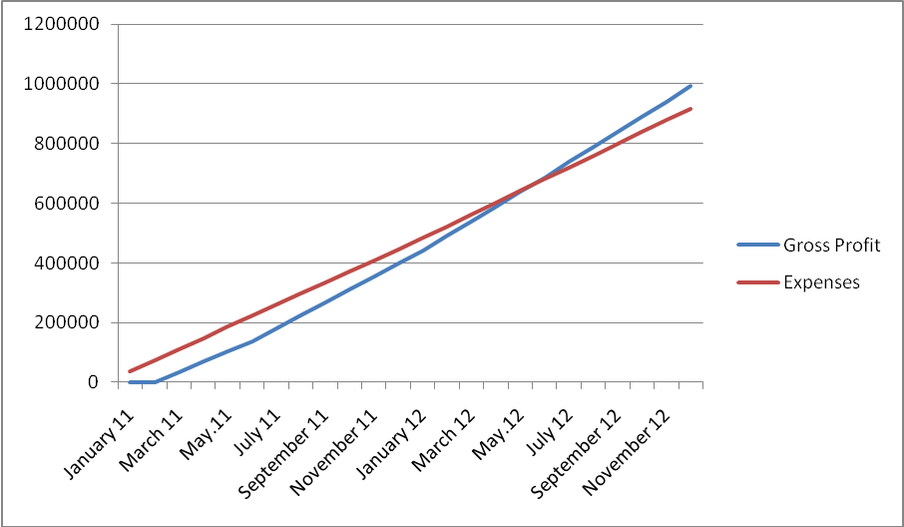

As it is shown on the chart, break-even point (intersection of lines) is between the months May, 2012 and June, 2012. That means 5E Electronic Co. starts to move into profit by selling goods.

  - Financial Ratios
All given ratios below are taken from Appendix H. All ratios are calculated annually.
- Gross Profit: That is the ratio of Gross Profit over net Sales. For the first year, the number of goods sold will be 1380 and the gross profit of goods sold is about 397.440 TL. When it is divided by revenue it can be found that Gross Profit Ratio is 48% and 5E Electronic Co. tried to make this ratio stable for the first five years.
- Operating Expenses: that ratio gives the rate of operating expenses over revenues. When it is calculated, it can be found that the ratio is 51% for the first year and over 36% for the rest years. The reason why operating expense ratio for the first year is greater than other years is that in the first two months of first year there will be no goods sold and the company loses from expenses. When sellings will be regular the ratio decreases.
- Net Income: For a new established company it is normal to bear a loss. Also 5E Electronic Co. will bear a loss for the first year about 6% but if the assumptions become real, the company will move into profit in second year.
- Operating Margin: That is the ratio between operating income and revenue. 5E Electronic Co. is not profitability for the first year but since the beginning of second year the company increases the ratio to 12%.

7.SWOT Analysis
7.1. Strengths
5E Electronic Corporation produces the electronic board in market and the target customers are private schools, universities and companies and the product we offer is the cheapest one in the market. Because of this cheapness of the product and importance of the electronic sector we are operating in, it is obvious that we will get a positive reaction from the customers when they start to use the product.
7.2. Weaknesses
The most obvious weaknesses that can be is inexperience of the establishers of 5E Electronic Co. because the establishers of the company are new graduated from university. Also as 5E Electronic Co. is a new established company, they lack the financial structure because there is no fund when the company was established.
7.3. Opportunities
The most important opportunity of 5E Electronic Co. is the price of the product. With successful marketing and sales strategies it would be easy to capture a high market share.
7.4. Threats
Biggest threat will be occur when the other firms decrease their price of the product because our brand is very new and it will not be known at the beginning. Customers will think that if there is a little difference in price they will buy the known brand.

8.Conclusion
5E Electronic Co is established by five enterprising new graduated people from different disciplines. Each person has different duties in the corporation and no one interferes to other person’s métier. All needed documents are prepared before the establishment and the plan is done for a five year period. When everything taken into consideration, it can be seen that 5E Electronic Corporation has the opportunity to become a leader in the market.

Appendices
Appendix A
Variable Costs
Equipment | Number of Unit | Price of One Unit | Total Price
Camera | 2 | 140 TL | 280 TL
USB Extension Cord | 2 | 5 TL | 10 TL
Pencil | 2 | 10 TL | 20 TL
Compact Disc | 1 | 1 TL | 1 TL
TOTAL |  |  | 311 tl

Appendix B
Sales Budgets

Appendix C
COGS Budget

Appendix D
Income Statements

Appendix E
Selling and Administrative Budget

Appendix F
Cash Flows

Appendix G
Profitability Ratios

Appendix H
Summary of Financial Projections

Appendix I
Development Plan
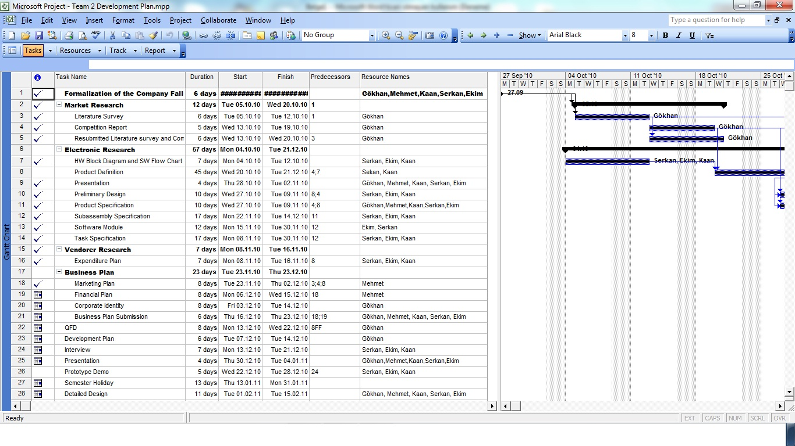
Table 1.A First Semester of Our Development Plan
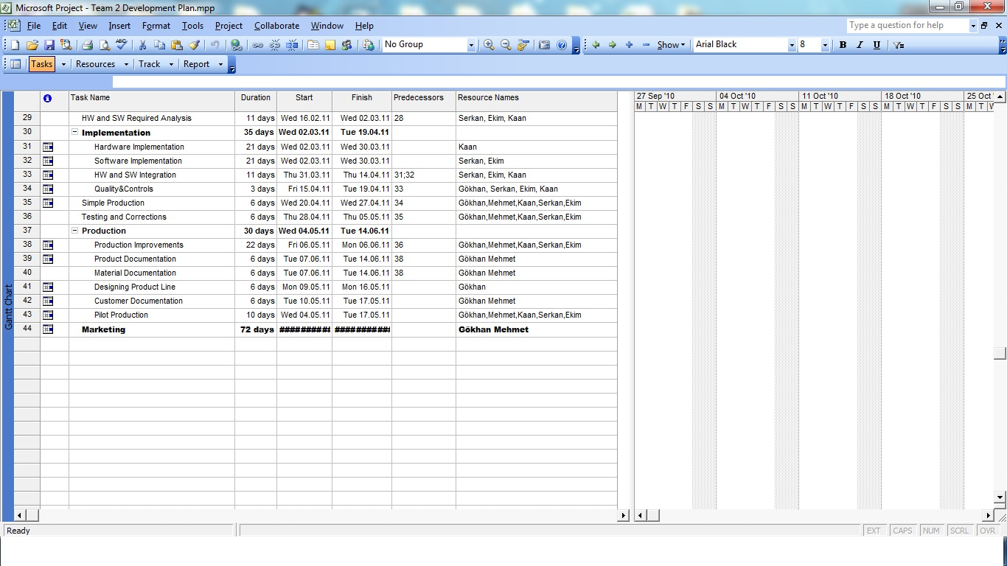
Table 2.A Second Semester of Our Development Plan
References
- sourceforge.net/projects/opencvlibrary/
- http://www.nap.edu/openbook.php?record_id=10094&page=281
- http://www.kaanguvenlik.com/online/Scripts/prodView.asp?idproduct=565
- http://2010-2011-fall.moodle.bilkent.edu.tr/course/view.php?id=259 QFD1
- Smart Draw Software for Surveys
- http://www.ozelokullardernegi.org.tr/basinda.php?id=2
- http://www.huseyinust.com/Thread-Turkiye%E2%80%99deki-yabanci-sermayeli-sirket-sayisi-26-bin-oldu
- http://www.nethaber.com/Ekonomi/107968/Turkiyedeki-universite-sayisi-139a-cikti
- http://www.electronicwhiteboardswarehouse.com/
- http://www.shopping.hp.com/webapp/shopping/product_detail.do?product_code=BU1402&aoid=8023&srccode=cii_13736960&cpncode=21-85040833-2
- ^{[2]}http://yapikredi.com.tr/tr-TR/MainPage.aspx
- ^{[1]}http://www.leventreklam.com.tr/gazete.htm
- http://en.wikipedia.org/wiki/Financial_ratio
- http://en.wikipedia.org/wiki/Break-even_(economics)

